OPC Client-VB6.0 sample
It accesses the OPC server via the automation wrapper of OPC.
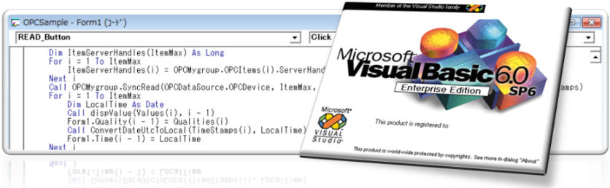

Hierarchy
The OPC server and the client application communicate each other through the interface of COM. The root class is OPC server object, and it accesses the group object and the item object by using this class.The device datas of PLC (ex. 'X0' and 'D0' etc.) are constructed at the low hierarchy, and you can access the device datas as the unit of item or collection.
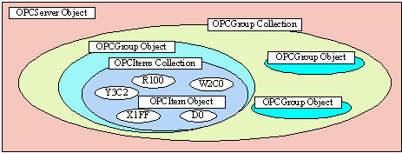

Register OPC automation dll
When the OPC server is set up, DLL necessary for OPC is automatically registered. For access to OPC Server from Visual Basic, it needs to check "OPC Automation 2.0".
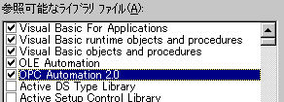

Declare OPC Objects (OPC Server / OPC Group / OPC Item)
For hooking events of OPC Server, add to "WithEvents" in dimension statement or event handler named "OBJECTNAME_EVENTNAME".
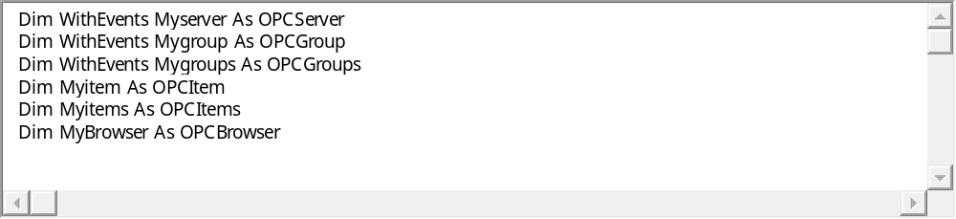

Get OPC Server List
It is able to get installed OPC Server name by using OPC Server object. In this sample, it shows OPC Server name in list box and operator can select the target server.
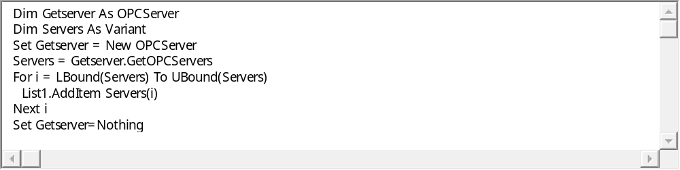

Connect and Browse
It is able to get device name registered in OPC Server by using OPC Server object. You can make the Group under device and OPC Server object is enabled to access this lower layer. 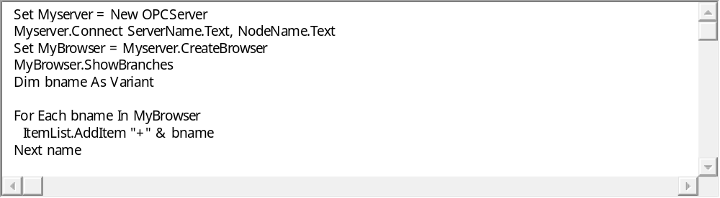

Create OPC Group Object and Add Tags
For accessing client application to physical device data, it needs to generate OPC Group object in OPC group collection. The OPC Group object can configure update interval of tags. Normally, the device of accessing same cycle will register in same group. Also, you should be carefully CPU performance to create over groups because OPC Server create a thread for each group.
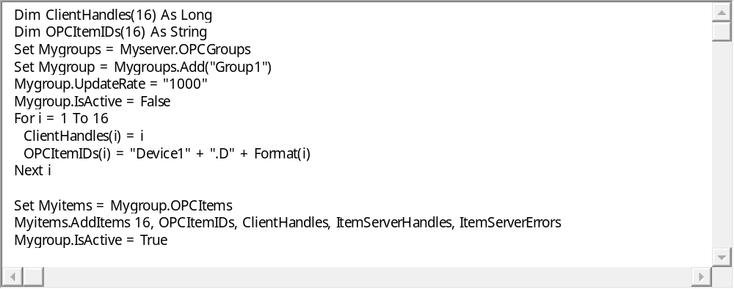

Advise and Callback
Implements event handler of OPC Group object for advice mode. The OPC Server read data for each cycle and if changing the value, callback to client application. The quality flag is normally '0xC0', when occurred error, it will be turn to other value.
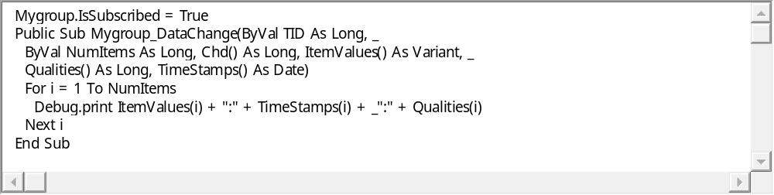

Sync Read/Write and ASync Read/Write
The OPC has two ways of data access, Synchronize and Asynchronous. In Synchronize, the client application must be wait for completing server work. But the client application can confirm server transaction is normally completed because the OPC Server returns the result on completing the communication work. This is a normally style of procedure.
In Asynchronous mode, the OPC Server turns the handle to client as soon as receiving the request and proceed the transaction on background. After completing this work, calls handler of client application. Asynchronous mode cut down wait time for communication and be able to run client application.
Caution: Asynchronous access is enabled under advice mode.
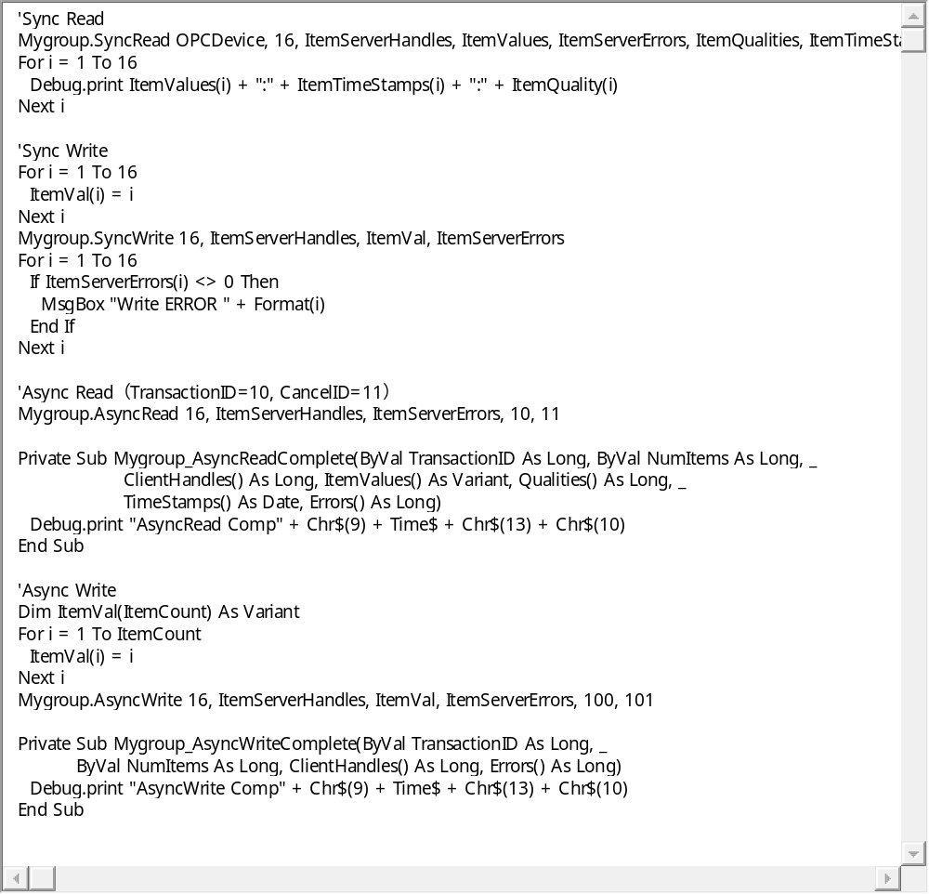

Cache Read
In cache read operation, OPC Server doesn't access the physical device and return the last data on memory. The OPC Server read and caches the value every each time.It will be able to access on high speed if not need newest value.
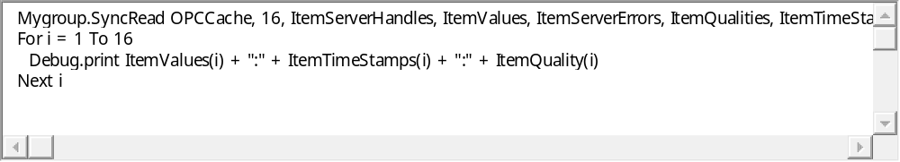

OPC Client - VB.NET Sample

It introduces the easy sample program using the OPC Server. The code of this sample uses OPC
If you access to OPC Server from .NET, the wrapper which exchanges COM and .NET is needed.
Automation Wrapper (OPCDAAUTO.DLL), so it is almost equal to VB6.0.
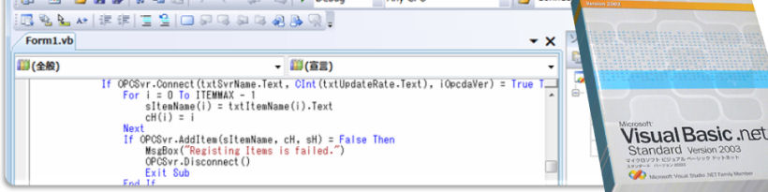
Declaration
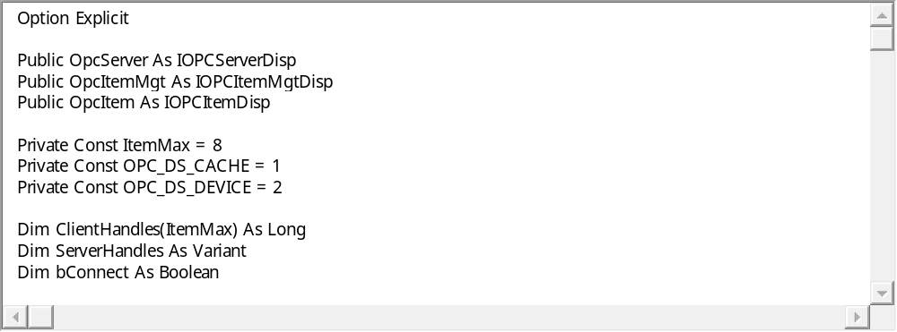
Connect to OPC Server, Create OPCGroup and Add Tags
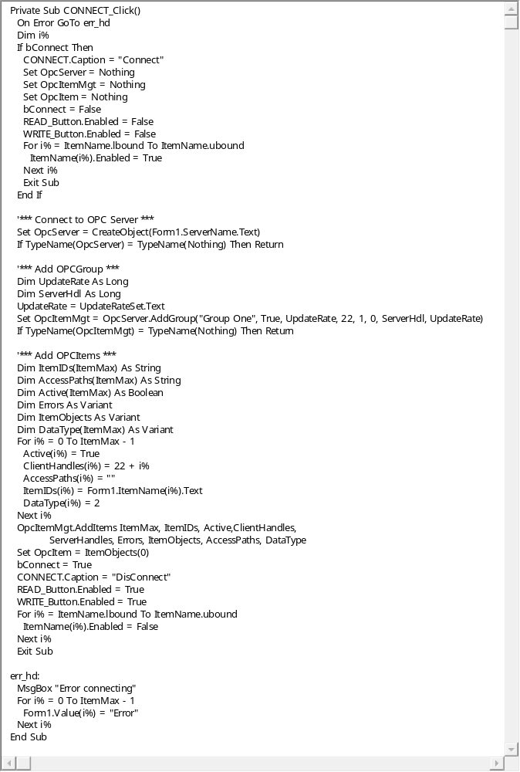
Cache Read
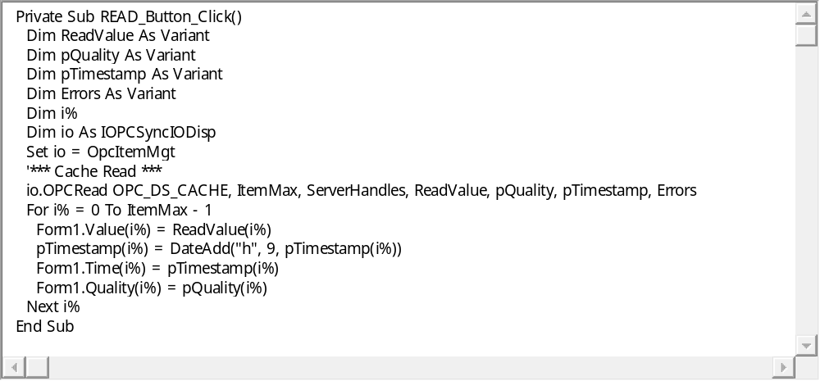
SyncWrite
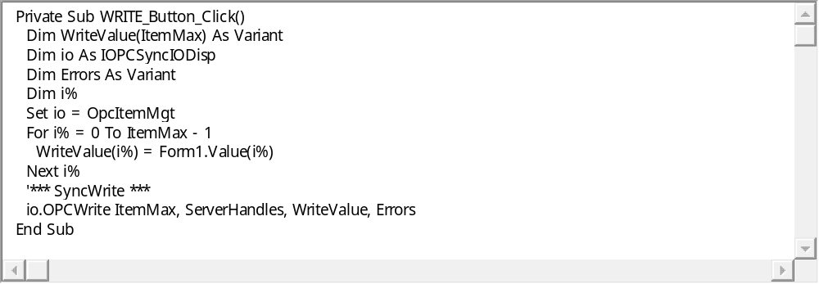

OPC client －C#.NET sample
If you access to OPC Server from .NET, the wrapper which exchanges COM and .NET is needed.
It explains the implementation of C#.NET accessed the OPC server by using RCW(Runtime Callble Wrapper) here.

Connect to OPC Server by COM
The instance of the COM connection is created specifying CLSID of the OPC server, and you can get each interface-pointers of OPC such as the OPC server objects and the browse objects etc.
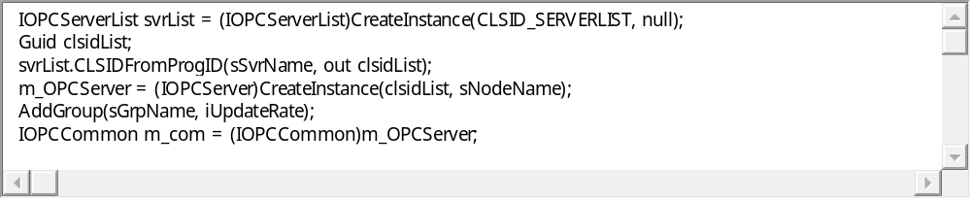

Create OPC Group and Add tags
It is necessary to create the group object in the OPC server to acquire real data from the outside.The data update cycle can be set to the group object, and usually register the device accessed by the same synchronization to the group. Because the threads of each group are created in the OPC server, please note CPU load increase by subdivision too much.
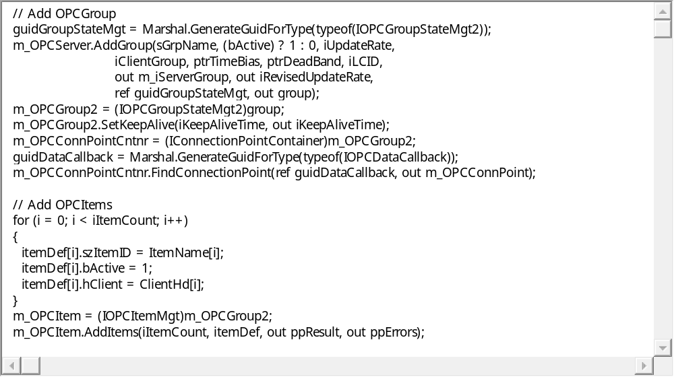

Sync Read/Write and ASync Read/Write
The OPC has two ways of data access, Synchronize and Asynchronous. In Synchronize, the client application must be wait for completing server work. But the client application can confirm server transaction is normally completed because the OPC Server returns the result on completing the communication work. This is a normally style of procedure.
In Asynchronous mode, the OPC Server turns the handle to client as soon as receiving the request and proceed the transaction on background. After completing this work, calls handler of client application. Asynchronous mode cut down wait time for communication and be able to run client application.
Caution: Asynchronous access is enabled under advice mode.
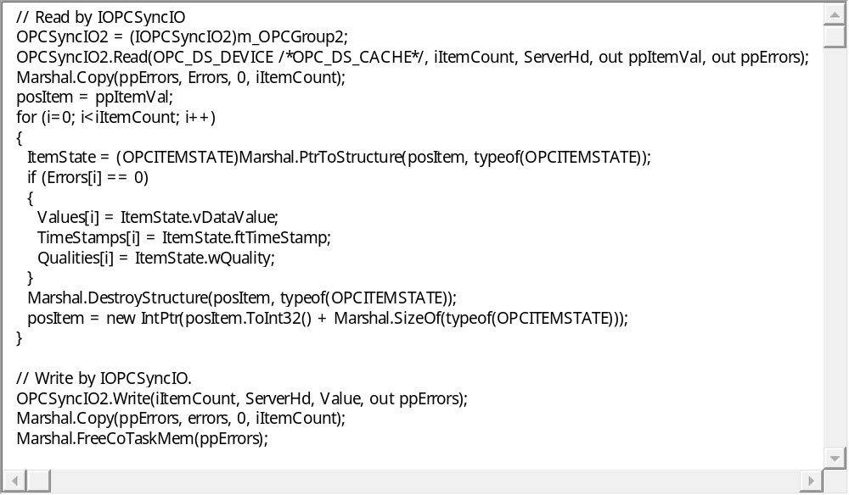
Cache read (OPC_DS_CACHE) immediately returns the latest data value on the server's memory without a communication. The OPC server automatically updates data according to the registered update cycle of each group. It becomes possible to high-speed access when it may not be necessarily the latest data.
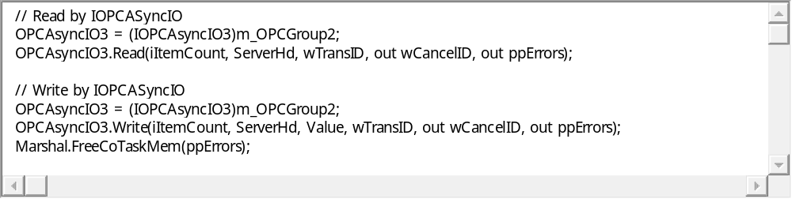

OPC Client - C++ Sample
It explains the implementation of C++ accessed the OPC server by using OPC custom interface here.

Connect to OPC Server by COM
The instance of the COM connection is created specifying CLSID of the OPC server, and you can get each interface-pointers of OPC such as the OPC server objects and the browse objects etc.
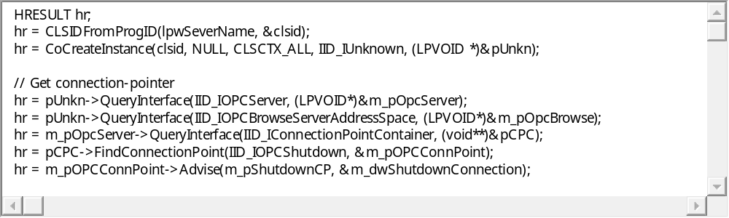

Create OPC Group Object and Add Tags
For accessing client application to physical device data, it needs to generate OPC Group object in OPC group collection. The OPC Group object can configure update interval of tags. Normally, the device of accessing same cycle will register in same group. Also, you should be carefully CPU performance to create over groups because OPC Server create a thread for each group.
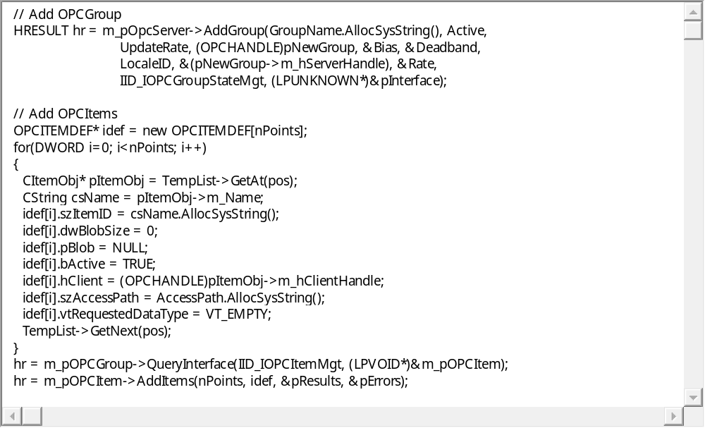

Sync Read/Write and ASync Read/Write
The OPC has two ways of data access, Synchronize and Asynchronous. In Synchronize, the client application must be wait for completing server work. But the client application can confirm server transaction is normally completed because the OPC Server returns the result on completing the communication work. This is a normally style of procedure.
In Asynchronous mode, the OPC Server turns the handle to client as soon as receiving the request and proceed the transaction on background. After completing this work, calls handler of client application. Asynchronous mode cut down wait time for communication and be able to run client application.
Caution: Asynchronous access is enabled under advice mode.
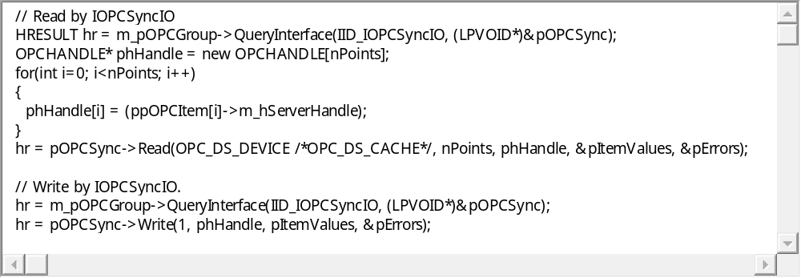
Cache read (OPC_DS_CACHE) immediately returns the latest data value on the server's memory without a communication. The OPC server automatically updates data according to the registered update cycle of each group. It becomes possible to high-speed access when it may not be necessarily the latest data.
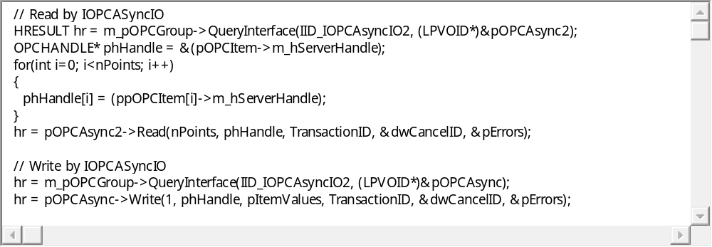

OPC Client-EXCEL/VBA sample
It accesses the OPC server via the automation wrapper of OPC.
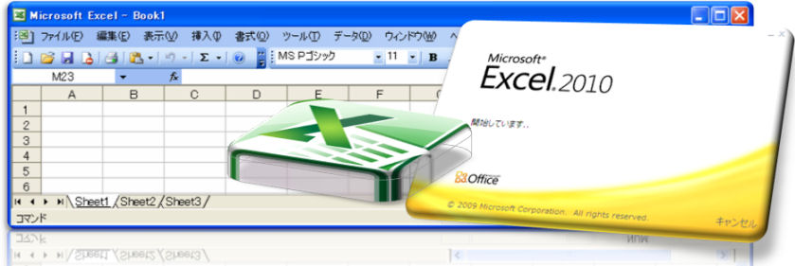

Declare OPC Objects (OPC Server / OPC Group / OPC Item)
For hooking events of OPC Server, add to "WithEvents" in dimension statement or event handler named "OBJECTNAME_EVENTNAME".


Connect and Browse
It is able to get device name registered in OPC Server by using OPC Server object. You can make the Group under device and OPC Server object is enabled to access this lower layer. 

Create OPC Group Object and Add Tags
It is necessary to create the group object in the OPC server to acquire real data from the outside.The data update cycle can be set to the group object, and usually register the device accessed by the same synchronization to the group. Because the threads of each group are created in the OPC server, please note CPU load increase by subdivision too much.
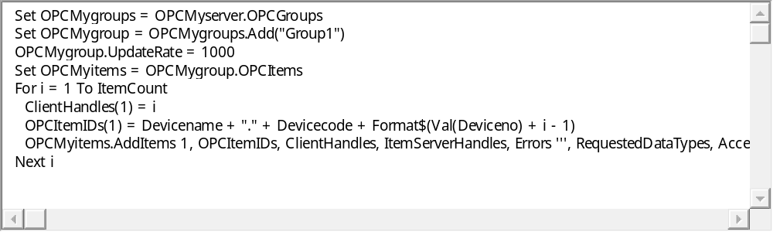

Advise and Callback
Implements event handler of OPC Group object for advice mode. The OPC Server read data for each cycle and if changing the value, callback to client application. The quality flag is normally '0xC0', when occurred error, it will be turn to other value.
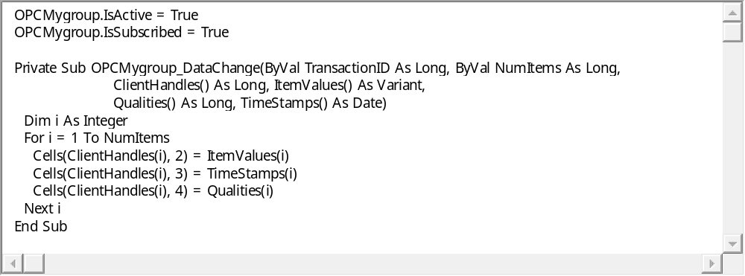

Sync Read/Write and ASync Read/Write
The OPC has two ways of data access, Synchronize and Asynchronous. In Synchronize, the client application must be wait for completing server work. But the client application can confirm server transaction is normally completed because the OPC Server returns the result on completing the communication work. This is a normally style of procedure.
In Asynchronous mode, the OPC Server turns the handle to client as soon as receiving the request and proceed the transaction on background. After completing this work, calls handler of client application. Asynchronous mode cut down wait time for communication and be able to run client application.
Caution: Asynchronous access is enabled under advice mode.
